Effects of a new biostimulant on gene expression and metabolic responses of tomato plants
V. Contartese¹, C. Garabello¹, A. Occhipinti², F. Barbero² and C.M. Bertea^{2,a}
¹Green Has Italia S.p.A, Canale (CN), Italy; ²Plant Physiology Unit, Department of Life Sciences and Systems Biology, University of Torino, Italy
ªE-mail: cinzia.bertea@unito.it

Abstract
The effects of a new biostimulant, EXPANDO®, containing different bioactive compounds such as mineral elements, amino acids, vitamins and phytohormone-like substances, potassium, phosphorus and molybdenum, developed mainly for fruit growth, were investigated both in greenhouse and open field experiments. The preliminary agronomic trials carried out on different crop species, including tomato, showed a plant growth promotion and an increase in final yield.
Since, no information were available on plants treated with this new biostimulant at transcriptomic level, we started a research project aimed to investigate the changes on gene expression in tomato plants (Solanum lycopersicum ‘Micro-Tom’) grown in growth chamber and treated twice with EXPANDO® (3.5 mL L⁻¹). To determine metabolic targets of this new biostimulant, a microarray analysis was carried out on EXPANDO®-treated and untreated 20-day old tomato plants. For expression profiling, Agilent Tomato Gene Expression Microarray (4x44K) and four biological replicates were used. A preliminary analysis of the microarray data showed that the treatment with EXPANDO® was able to modulate the expression level of about 4,000 genes (>1,700 up-regulated and >2,000 down-regulated) which were found to be involved in several biological processes like transcription, stress responses, signal transduction, carbohydrate metabolism, transport, protein metabolism and secondary metabolism. Moreover, to investigate the metabolic responses of tomato to EXPANDO® treatment and the possible correlation with trascriptomic analyses, several biochemical parameters such as content of soluble proteins, photosynthetic pigments, total phenolic compounds and activity of three ROS scavenging enzymes (superoxide dismutase, peroxidase and catalase) were evaluated on control and treated plants.
In general, EXPANDO® did not affect the level of the metabolites in analysis, at least in growth chamber conditions, however, the treatment enhanced the modulation of the ROS scavenging enzyme genes, since a good correlation was found between the level of transcripts and the enzyme activity.

Keywords: Solanum lycopersicum, EXPANDO®, microarray analysis, soluble proteins, photosynthetic pigments, total phenols, ROS scavenging enzymes

INTRODUCTION
Research activities in agriculture are focused on increasing yields while taking in consideration the sustainability of the cultivation systems. Biostimulants are molecules that are often referred to positive plant growth regulators or metabolic enhancers. There are several categories of biostimulants, such as products based mainly on microbial inoculants, humic and fulvic acids, protein hydrolysates and amino acids, vitamins and seaweed extracts (du Jardin, 2015). Biostimulants have been gaining interest in sustainable agriculture because their application activates several physiological processes that enhance nutrient use efficiency, stimulates plant development and allows the reduction of traditional fertilizer consumption (Kunicki et al. 2010).
EXPANDO®, a new biostimulant that contains different bioactive compounds such as amino acids, vitamins, cytokinin-like substances, potassium, phosphorus and molybdenum, was developed to promote fruit growth. Each component of this new biostimulant works sinergically to trigger different metabolic processes.
Cytokinins are phytohormones able to promote cell division and expansion. These molecules interact with the other classes of plant hormones to stimulate and coordinate fruit development. The amino acids promote nitrogen assimilation in plants via coordinated regulation of carbon and nitrogen metabolism. Hydrolysated products based on plant origin amino acids contain mainly glutamic acid (Calvo et al., 2014). Glutamate occupies a central position in amino acid metabolism in plant. Thanks to a reversible process known as transaminase reaction, different amino acids are originated from it. The amino acids generated from this process could be aspartate or member of the aspartate family (lysine, threonine, methionine and isoleucine), alanine, glycine, serine, proline and arginine.
The vitamins, a diverse group of organic molecules, are important antioxidant compounds and act as enzyme cofactors. EXPANDO® contains B-group vitamins that take part in the Krebs cycle and enhance nitrogen assimilation. The organic components are enriched with mineral compounds (P, K and microelements).
EXPANDO® has been investigated both in greenhouse and open field over a period of three years. The test of EXPANDO® on table grape, variety Italia, in 2014 showed a significantly better result with respect to untreated controls in terms of bunch length and weight, berry weight and sugar content. The results of EXPANDO® were comparable to those obtained with the reference gibberellic acid-based product.
Similar results were observed with pepper and tomato trials. The plants treated with EXPANDO® showed an higher number of induced flowers and set fruits and produced fruits with significantly higher sugar content and higher average weight in comparison to the untreated controls. Furthermore, it was observed a significant increment of pulp thickness on pepper, whereas on tomato a remarkable increment in terms of weight and number of the yield of marketable fruits (V. Contartese pers. Commun., 2015).
To better understand the effects of EXPANDO® on plant growth and development, a transcriptomic analysis (microarray) along with some biochemical parameter measurements were carried out. This approach allowed the identification of specific genes or groups of genes that were up- or down-regulated when tomato plants were treated with EXPANDO®.

MATERIALS AND METHODS
Plant material, growth conditions and treatments
Individual Solanum lycopersicum ‘Micro-Tom’ plants were grown in a plastic pot with sterilized potting soil in a growth chamber at 25±2°C (day) and 22±2°C (night) and 60±10% relative humidity using daylight fluorescent tubes (200 µmol m⁻² s⁻¹) with a photoperiod of 12 h light/12 h dark. Two foliar treatments (3.5 mL L⁻¹ EXPANDO®, 5 and 15 days after transplanting) were utilized. No surfactant was added in any treatment. Treatment application was done using a hand sprayer until all leaf surfaces were wetted. Control treatments consisting of distilled water spray application were also included.

RNA extraction from tomato leaves and gene microarray analyses
Leaves were collected 5 days after the last treatment and immediately frozen in liquid nitrogen. Samples for the evaluation the of the biostimulant effect were sampled after 5 days from treatment. Four biological replicates were run for each tested treatment. One hundred mg of frozen leaves were ground to powder in liquid nitrogen. Total RNA was isolated using the Agilent Plant RNA Isolation Mini Kit (Agilent Technologies, Santa Clara, CA, US) and RNase-Free DNase set (Qiagen, Hilden, Germany). Sample quality and quantity was checked by using the RNA 6000 Nano kit and the Agilent 2100 Bioanalyzer (Agilent Technologies) according to manufacturer’s instructions. Quantification of RNA was also confirmed spectrophotometrically by using a NanoDrop ND-1000 (Thermo Fisher Scientific, Waltham, MA, US). One hundred nanograms of total RNA from each control and biostimulant-treated samples, were separately reverse-transcribed into double-strand cDNAs by the Moloney murine leukemia virus reverse transcriptase (MMLV-RT) and amplified for 2 h at 40°C using the Agilent Low Input Quick-Amp Labelling Kit, two-color (Agilent Technologies, Santa Clara, CA, US). Subsequently, cDNAs were transcribed into antisense cRNA and labeled with either Cy3-CTP or Cy5-CTP fluorescent dyes for 2 h at 40°C following the manufacturer’s protocol.
Cyanine-labeled cRNAs were purified using RNeasy Minikit (Qiagen, Hilden, Germany). Purity and dye incorporation were assessed with the NanoDrop ND-1000 UV-VIS Spectrophotometer (Thermo Fisher Scientific, Waltham, MA, US) and the Agilent 2100 Bioanalyzer (Agilent Technologies). Then, 825 ng of control Cy3-RNAs and 825 ng of treated Cy5-RNAs were pooled together and hybridized using the Gene Expression Hybridization Kit (Agilent Technologies) onto 4x44K Tomato Oligo Microarray (Agilent Technologies).
After a 17 h incubation at 65°C and 10 rpm, microarrays were first washed with the Gene Expression Wash buffer 1 for 1 min, then with Gene Expression Wash buffer 2 for 1 min, then with 100% acetonitrile for 30 s, and finally washed in the Stabilization and Drying Solution for 30 s.
Microarrays were scanned with the Agilent Microarray G2505B Scanner (with the extended dynamic range (XDR) scan mode to scan the same slide at two different levels and data were extracted and normalized from the resulting images using Agilent Feature Extraction (FE) software (v.11.0)

ROS-Scavenging Enzyme Activity
ROS scavenger enzymes were extracted following the method described by Maffei et al. (2006). All operations were carried out at 4°C. Plant material was ground with mortar and pestle under liquid nitrogen in cold 50 mM sodium phosphate, pH 7.5, containing 250 mM Sucrose, 1.0 mM EDTA, 10 mM KCl, 1.0 mM MgCl₂, 0.5 mM phenylmethylsulfonyl fluoride (PMSF), 0.1 mM dithiothreitol (DTT), and 1% (w/v) polyvinylpolypyrrolidone (PVPP) in a 1:10 proportion (w/v). The homogenate was then filtered through eight layers of cheesecloth and centrifuged at 25,000g for 20 min at 4°C. The supernatant was brought to 80% saturation with addition of solid ammonium sulfate (NH₄)₂SO₄ and allowed to stir gently for several hours at 4°C. After centrifugation at 28,000g for 45 min at 4°C, pellets, containing most of enzyme activity, were resuspended in a small volume of 50 mM sodium phosphate, pH 7.5, and used directly for enzyme assays.
The activity of superoxide dismutase (SOD, EC 1.15.1.1) was measured according to Krishnan et al. (2002). This method tests the ability of SOD to inhibit the reduction of nitro blue tetrazolium by the superoxide anion generated photochemically. One milliliter of assay mixture consisted of 50 mM sodium phosphate buffer, pH7.8, 13 mM methionine, 75 µM nitro blue tetrazolium, 2 mM riboflavin, 0.1 mM EDTA, and enzyme extract. Riboflavin was added last, the samples were placed 30 cm below a light source (4,000 lux), and the reaction was allowed to run for 15 min. The reaction was stopped by switching off the light. A non irradiated reaction mixture, which was run in parallel, did not develop color and served as a control. The absorbance was read at 560 nm.
Catalase (CAT, EC 1.11.1.6) activity was assayed spectrophotometrically by monitoring the change in A₂₄₀ due to the decreased absorption of H₂O₂ (ɛ H₂O₂ = 39.4 mM⁻¹ cm⁻¹). The reaction mixture in 1 mL final volume contained 50 mM sodium phosphate buffer, pH 7.0, 15 mM H₂O₂, and enzyme extract. The reaction was started by addition of H₂O₂.
Peroxidase (POX, EC 1.11.1.7) activities were measured as oxidation of guaiacol (ɛ guaiacol = 26.6 mM mM⁻¹ cm⁻¹) in the presence of H₂O₂. The reaction mixture contained 50 mM sodium phosphate, pH 7.0, 0.33 mM guaiacol, 0.27 mM H₂O₂, and enzyme extract in 1.0 mL final volume. The reaction was started by addition of guaiacol and followed spectrophotometrically at 470 nm.

Protein, total phenol and photosynthetic pigment determination
Protein content was quantified according to Bradford (1976), using bovine serum albumin (BSA) as standard. Total phenols were determined according to Dolzhenko et al. (2010) with the Folin Ciocalteau reagent using rutin as standard. Phosynthetic pigments were determined according to Lichtenthaler et al. (1987) using ethanol (95%).

Statistics
Preliminary statistical analysis of raw microarray data were performed using GeneSpring Vers. 13. Benjamini and Hochberg (BH) multiple testing correction was applied. We consider genes with both BH adjusted p-value < 0.05 and fold changes > 2 as differentially expressed genes.
The overall data sets related to the other analyses were expressed as mean values of at least three biological replicates. Three technical replicates were run for each biological replicate. Metric bars indicate standard error. ANOVA and Tukey–Kramer’s HSD test (p<0.05) were used to determine significant differences among treatments using the SYSTAT 10 software.

RESULTS AND DISCUSSION
GO functional analysis of differentially expressed genes upon EXPANDO® treatment
RNA isolated from EXPANDO®-treated and control plants was hybridized on the Agilent Tomato Gene Expression Microarray 4x44K. To reduce the biological variability, four biological replicates for each condition, each consisting of pools of three plants, were processed in parallel. Analysis of the Agilent Two-Color RNA Spike-In Plot demonstrated similar and good performance of each single labelling and hybridization experiment, with consistency of data being confirmed by MA plots (data not shown). Genes with a p-value < 0.05 and fold changes > 2 were considered differentially expressed. According to this criterion, we identified 4,146 genes differentially expressed (DE) between treated and control plants: 1,731 were up-regulated by the treatment with the biostimulant and 2,415 were down-regulated. To characterize the function of genes differentially expressed in treated plants, the array data were organized in functional categories according to Gene Ontology guidelines using Uniprot (The Uniprot Consortium, 2015). (Figure 1).

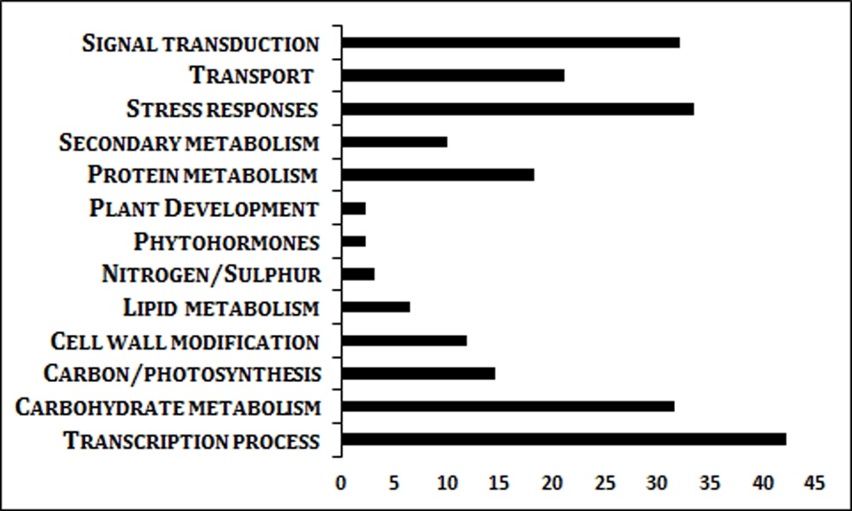
Figure 1. Genes differentially expressed in EXPANDO®-treated plants with respect to controls. Bars represent the percentage of regulated genes.
Among the genes modulated by EXPANDO® treatment, we observed a significant number of those involved in transcription process (>40%). Other categories highly represented were the stress responses (>35%), signal transduction (>30%) and carbohydrate metabolism (>30%).
In particular, in the transcription process category we could find up-regulated few MYB factors and homeobox leucine-zipper proteins. Among the genes down regulated in this category we could find the AREB-like protein, a transcription factor that participates in the regulation of the metabolic programming that takes place during fruit ripening (Bastías et., 2014). Down regulated was also the ein3-binding f-box protein 1 (EBF1), shown to function in ethylene perception by regulating EIN3/EIL turnover (Konishi and Yanagisawa, 2008). The analysis of overrepresented functional categories also highlighted a significant enrichment, among the biostimulant-induced DE genes, of those involved in stress responses: several isoforms of pathogen-related proteins (PR1, PR4, PR5) were up-regulated, whereas few genes coding for heat shock proteins (HSP70 and HSP90) were down-regulated by the treatment. In general, plants upregulate heat shock proteins in response to environmental stresses (Al-Whaibi, 2011). The pronounced downregulation of heat shock proteins after EXPANDO® treatment indicates that this biostimulant does not induce stress and contributes to protect plants from other stress.
Among the genes coding for reactive oxygen species (ROS) scavenging enzymes, an isoform of superoxide dismutase (SODCP.2) and a peroxidase (CEVI-1) were slightly up-regulated by EXPANDO® (fold change 2,07 and 2,19, respectively), whereas the catalase 2 (CAT2) was strongly down-regulated (fold change -4,85). These results confirm EXPANDO® potential antioxidant action on plants.
With regard to signal transduction category, the calmodulin SUN-like protein was up-regulated along with the auxin response factor 5 (ARF5). Auxin response factors (ARFs) are transcriptional factors involved in growth and developmental processes. In particular, ARF5 is critically required for flower formation (Li et al., 2016).
Finally, the functional category carbohydrate metabolism was overrepresented among the up-regulated genes: the transcription of five isoforms of expansin (EXP 1, 8, 9, 11, and 12) and two isoforms of pectine esterase (PM1.9 and PM 2.1) was positively regulated. Expansins are cell wall proteins implicated in the control of plant growth via loosening of the extracellular matrix. Expansins are required for leaf growth and a decreased expansin gene expression leads to a more marked repression of growth during the later stage of leaf development (Cosgrove, 1998). With regard to pectine esterases, various experiments have demonstrated that PMEs are involved, directly and indirectly, in diverse physiological processes associated with both vegetative and reproductive plant development (Pelloux et al., 2007). EXPANDO® probably promotes the plant growth and development, through the modulation of a number of genes involved in cell wall modification. Among the down-regulated genes in this functional category, we could find a beta-galactosidase and a beta fructosidase. These two genes are mainly related to fruit ripening.

Photosynthetic pigment, soluble protein and total phenol determination
In EXPANDO®-treated plants, no significant differences were observed in photosynthetic pigment content with respect to controls (Figure 2). Similar results on chlorophyll level, were obtained by Jannin et al. (2012) with Winter rapeseed (Brassica napus) treated with humic acids. In the same way, EXPANDO® did not affect the production of soluble proteins and total phenolic compounds. In both cases, we could observe a decrease in their content, however the results were not significant between EXPANDO®-treated and control plants (Figure 2). The lower amount of phenols measured after the treatment, although not significant with respect to control, was actually in correlation with the expression level of genes involved in flavonoid and other phenolic compound biosynthesis. In fact, a number of genes related to the pathways of these secondary metabolites were found to be down-regulated. These results could be explained by the fact that we sprayed EXPANDO® on healthy plants, not under stress conditions and cultivated in the growth chamber, a stable environment.
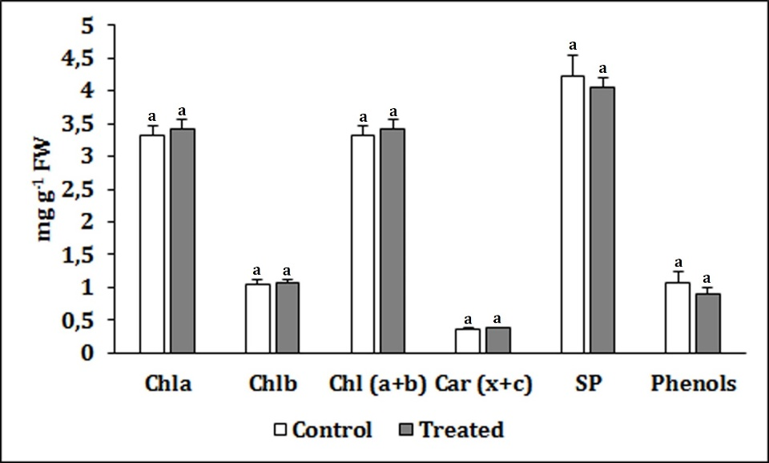
Figure 2. Photosynthetic pigment, soluble protein and total phenol content. The data are expressed as mg g⁻¹ fresh weight. Chla = chlorophyll a, Chlb = chlorophyll b, Car (x+c) = carotenoids (xanthophylls + carotenes). SP = soluble proteins. Metric bars indicate standard error (SE). In each graph, same letter indicates not significant differences (p<0.05).

ROS-Scavenging Enzyme Activity
SOD, CAT and POX specific activities were modulated by EXPANDO®-treatment. In particular, SOD and POX activities increased following the treatment with respect to the control. CAT specific activity was also correlated to the biomolecular data. We observed an activity decreased in plants treated with EXPANDO® (Figure 3). These biochemical data are in accordance with our preliminary molecular biological results obtained by microarray analysis. The results gave a first indication of the effect of EXPANDO®-treatments on the expression of genes and enzymatic activity of proteins involved in ROS scavenging in tomato plants.

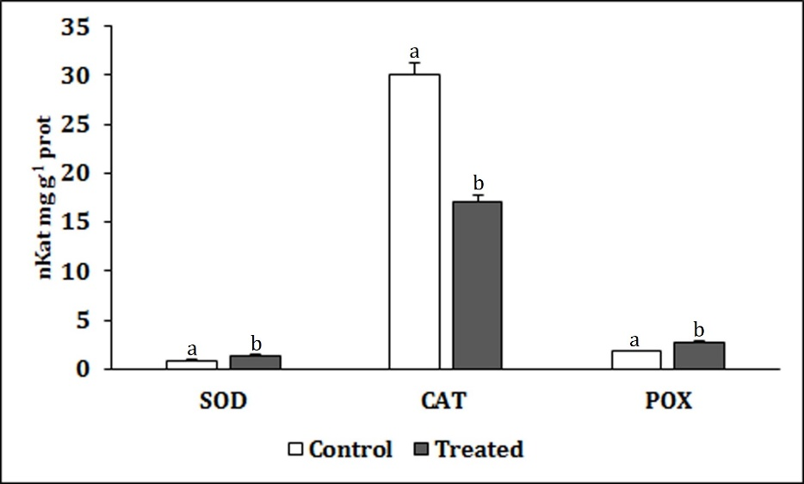
Figure 3. Activity of ROS-scavenging enzymes in control and EXPANDO®-treated tomato plants. Superoxide dismutase (SOD), catalase (CAT) and peroxidase (POX). Enzymatic activities are expressed as nKat mg g⁻¹ prot. Metric bars indicate standard error (SE). In each graph, different letters indicate significant differences (p<0.05).
In general, EXPANDO® did not show a strong effect on the vegetative phase of the plant at least at the time of application and plant growth conditions used.

CONCLUSIONS
The following conclusions can be drawn from the study:
­ in tomato ‘Micro Tom’ more than 4,000 genes were significantly modulated by EXPANDO® treatment (>1,700 up-regulated; >2,400 down-regulated).
- some biochemical parameters (protein, photosynthetic pigment and phenolic compound content) did not change significantly following EXPANDO® treatment compared to control. However, ROS scavenging enzyme activities (SOD, POX and CAT) were in correlation with the gene expression levels.
- this study combining microarray and physiological analyses to explain effects on tomato growth gives clues about the metabolic targets of EXPANDO®, however further investigations are still necessary to improve our knowledge on the mechanisms underlying the response of plants to this new biostimulant.

Literature cited

Al-Whaibi, M.H. (2011) Plant heat-shock proteins: A mini review. Journal of King Saud University – Science, 23, 139–150
Bastías, A., Yañez, M., Osorio, S., Arbona, V., Gómez-Cadenas, A., Fernie, A.R., Casaretto, J.A. (2014). The transcription factor AREB1 regulates primary metabolic pathways in tomato fruits. J. Exp. Bot. 65, 2351–2363 http://dx.doi.org/10.1093/jxb/eru114
Bradford, M.M. (1976) A rapid and sensitive method for the quantitation of microgram quantities of protein utilizing the principle of protein-dye binding. Anal Biochem 72, 248–254

Cosgrove, D.J. (1998). Cell wall loosening by expansins. Plant Phys. 118, 333-339

Dolzhenko, Y., Bertea, C.M., Occhipinti, A., Bossi, S., Maffei, M. (2010). UV-B modulates the interplay between terpenoids and flavonoids in peppermint (Mentha x piperita L.). Journal of Photochem Photobiol. B: Biology, 100, 67-75 http://dx.doi.org/10.1016/j.jphotobiol.2010.05.003

du Jardin, P. (2015) Plant biostimulants: Definition, concept, main categories and regulation. Scientia Horticulturae. 196, 3-14

Jannin, L., Arkoun, M., Ourry, A., Laîné, P., Goux, D., Garnica, M., Fuentes, M., San Francisco, F., Baigorri, R., Cruz, F., Houdusse, F., Garcia-Mina, J-M., Yvin, J-C., Etienne, P. (2012). Microarray analysis of humic acid effects on Brassica napus growth: Involvement of N, C and S metabolisms. Plant Soil 359, 297–319

Konishi, M. and Yanagisawa, S. (2008). Ethylene signaling in Arabidopsis involves feedback regulation via the elaborate control of EBF2 expression by EIN3. Plant J. 55, 821–831 http://dx.doi.org/10.1111/j.1365-313X.2008.03551.x

Krishnan, N., Chattopadhyay, S., Kundu, J.K., Chaudhuri, A. (2002) Superoxide dismutase activity in haemocytes and haemolymph of Bombix mori following bacterial infection. Curr Sci 83, 321–325

Kunicki, E., Grabowska, A., Sękara A., Wojciechowska, R. (2010). The effect of cultivar type, time of cultivation, and biostimulant treatment on the yield of spinach (Spinacia oleracea L.). Folia Hort. 22/2, 9-13.

Li, S-B., Xie, Z-Z., Hu, C-G., Zhang, J-Z. (2016). A Review of Auxin Response Factors (ARFs) in Plants. Front. Plant Sci,. 7, 47. http://dx.doi.org/10.3389/fpls.2016.00047

Lichtenthaler, H.K. (1987) Chlorophylls and carotenoids: pigments of photosynthetic biomembranes. Methods in Enzymology, 148, 350-382

Maffei, M.E., Mithöfer, A., Arimura, G., Uchtenhagen, H., Bossi, S., Bertea, C.M., Starvaggi Cucuzza, L., Novero, M., Volpe, V., Quadro, S., Boland, W. (2006). Effects of feeding Spodoptera littoralis on lima bean leaves. III. Membrane depolarization and involvement of hydrogen peroxide. Plant Physiol 140, 1022-1035.

Pelloux, J., Rustérucci, C., and Mellerowicz, E.J. New insights into pectin methylesterase structure and function. Trends Plant Sci. 12, 267-277

The Uniprot Consortium (2015). UniProt: a hub for protein information. Nucl. Acids Res. 43, D204-D212 http://dx.doi.org/10.1093/nar/gku989

